Q.1Explain the difference between frontend, backend, and full-stack development with
suitable real-world examples.

Frontend is everything you see and touch on a website — the colors, buttons, layout, design. Like when you open Instagram, the screen you see is the frontend.
Backend is what happens behind the scenes — storing data, checking your password, talking to the database. You don't see this part.
A full-stack developer can do both jobs — frontend and backend.
Example: On Zomato, the restaurant cards you see are the frontend. When you place an order and the payment goes through, that's the backend working.
Q.2 Create a simple diagram showing how the client-server model works in web architecture.

(Diagram shown above)
In simple words: you type something in your browser (that's the client), it sends a request to the server, the server processes it and sends the data back, and your browser shows it to you.
Q.3 Describe how a browser requests and displays a web page from a web server.
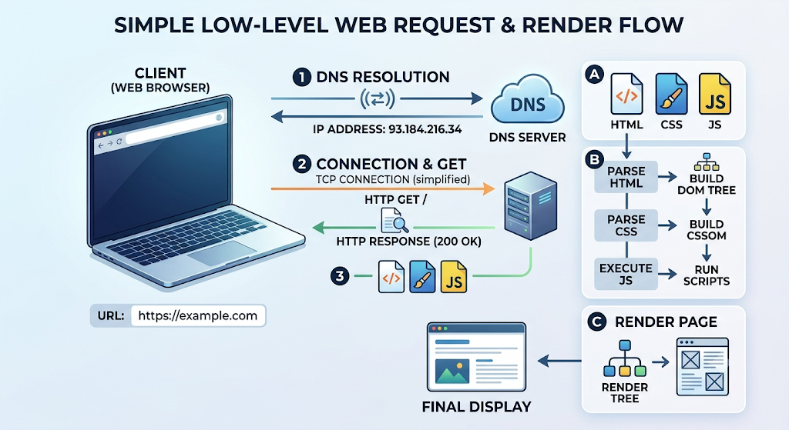
- First, the browser turns the website name (like google.com) into an IP address (this is called DNS lookup)
- Then it connects to the server
- It asks the server "give me this page"
- The server finds the file or creates it, and sends it back
- The browser reads the HTML and CSS to build the page's structure and design
- It shows everything on your screen
- If there's JavaScript, that runs too and makes the page interactive
Q.4 Identify and list the tools required to set up a web development environment. Explain the
purpose of each.
- VS Code — for writing code
- Browser (Chrome) — for checking your website and finding errors using developer tools
- Git — keeps track of changes you made to your code, and when
- GitHub — saves your code online so you can share it with your team
- Node.js — lets JavaScript run outside the browser
- Live Server extension — automatically refreshes the browser when you save your code
- Terminal — for running commands
- Postman — for testing APIs
5. What is a web server?
A web server is software that stores website files and sends them back whenever a browser asks for them.
Common web servers: Apache, Nginx, Microsoft IIS, and Node.js (with Express).
6. Who does what in a team
- Frontend developer — builds the design and what users see
- Backend developer — writes the server's logic and connects it to the database
- Database Administrator (DBA) — manages the database, keeps data safe, and takes backups
7. Installing VS Code
I can't install it myself since I don't have a screen, but here are the steps — go to code.visualstudio.com, download it, add a few extensions (like Live Server and Prettier), and open your project folder to start working.
8. Static vs Dynamic websites
A static website has fixed content — it looks the same for everyone. Like a simple portfolio site.
A dynamic website's content changes based on the user, pulled from a database. Like Amazon — every user sees different recommendations.
9. Five web browsers and their rendering engines
- Chrome → Blink engine
- Firefox → Gecko engine
- Safari → WebKit engine
- Edge → Blink engine (used to have its own engine, now it's like Chrome)
- Opera → Blink engine
Simply put: most browsers (Chrome, Edge, Opera, Brave) all use the Blink engine, so websites look almost the same on all of them. Only Firefox and Safari use their own separate engines.
10. Full web architecture flow
(Diagram shown above)
In simple words: The client sends a request → the server handles it → the server calls the API → the API gets data from the database → and the data travels back the same way to the client.

Want me to turn this whole thing into a Word document or PDF you can submit?

